AG-3
Cyber Resilience for an Agribusiness Back Office
AG3 Prototype Testing and Validation Report

COIT20265 Networks and Information Security Project

Group PG5
CQUniversity Australia

Contents
1 Introduction 3
2 Prototype Validation Scope 3
3 Prototype Test Environment 3
3.1 Prototype Setup 4
4 Testing Method 4
5 Prototype Setup and Integrated Validation 4
5.1 Office PC Access to APP01 5
5.2 Authentication Monitoring 6
5.3 File Integrity Monitoring 6
5.4 Successful Backup 8
5.5 Controlled Backup Failure 10
5.6 Backup Stored in MinIO 12
5.7 Controlled Ransomware-Like File Impact and Recovery Test 13
5.8 What the Integrated Tests Proved 19
6 Firewall and Segmentation Validation 19
7 Application and Access-Control Validation 20
8 Problems Found and Resolved During Testing 20
9 Consolidated Validation Results 21
10 Requirements Traceability 21
11 Validation Limitations 22
12 Conclusion 22
Appendix A - Recorded Demonstration Evidence 23

1 Introduction
The AG-3 prototype was developed to demonstrate the ability of the primary cyber-resilience controls to co-exist in a single ecosystem. It is a small-scale version of the envisioned agribusiness back-office network that concentrates on the systems that could be constructed and tested within the team's current equipment portfolio.
The prototype consists of pfSense firewall APP01, MON01 and BKP01. APP01 is the business file service for Nextcloud, and also initiates the backup process. MON01 is the Wazuh monitoring. The MinIO backup repository and restic backup repository are stored in BKP01. The TP-Link LS108G unmanaged switch has been used just for the physical connection between the devices. pfSense and its host interfaces are used to provide logical separation and traffic control.
This report describes the prototype configuration, the procedure followed for each validation test, the outcome of the test and the significance of the test outcome. The tests follow the same order in which the prototype is operated: user access to APP01, authentication monitoring, File Integrity Monitoring, successful and failed backup behaviour, backup storage in MinIO and controlled ransomware-like file impact and recovery demonstration.

2 Prototype Validation Scope
Validation scope: Only the functions implemented and demonstrated in the prototype are covered. Components that are a part of the target design are not considered implemented unless part of the working test environment.
Included in prototype validation | Outside the implemented prototype
pfSense routing, VLAN interfaces and firewall service paths | Full production-scale office deployment
Office PC access to APP01 Nextcloud | Managed production switching and switch-port VLAN enforcement
Nextcloud application and role-based access | AUTH01, NAS01 and other target-only systems
Wazuh authentication and File Integrity Monitoring | CCTV, RFID, NVR and optional Guest Wi-Fi
Successful and failed Restic backup behaviour | High-availability firewall and switching
Backup storage in MinIO on BKP01 | Real ransomware or destructive malware
Controlled ransomware-like file impact, detection and recovery using synthetic files | Full production IPv6 deployment

3 Prototype Test Environment
Component | Role | Prototype address / network | Technology
Firewall | Routing, segmentation and policy | 10.20.x.1 gateways | pfSense
APP01 | Business application / file server | 10.20.20.10 | Ubuntu + Nextcloud + Restic client
MON01 | Monitoring server | 10.20.30.10 | Wazuh
BKP01 | Backup server / repository | 10.20.40.10 | MinIO + Restic repository
Office PC | User access to Nextcloud | 10.20.10.10/24 | Windows client
Switch | Physical connectivity only | N/A | TP-Link LS108G unmanaged

3.1 Prototype Setup
The final physical configuration is with separate devices for the Office PC, APP01, MON01, and BKP01. The switch was used for physical connectivity between devices and the router was used for upstream connectivity. The same setup was applied when performing the integration and controlled file-impact demonstrations based on the ransomware.
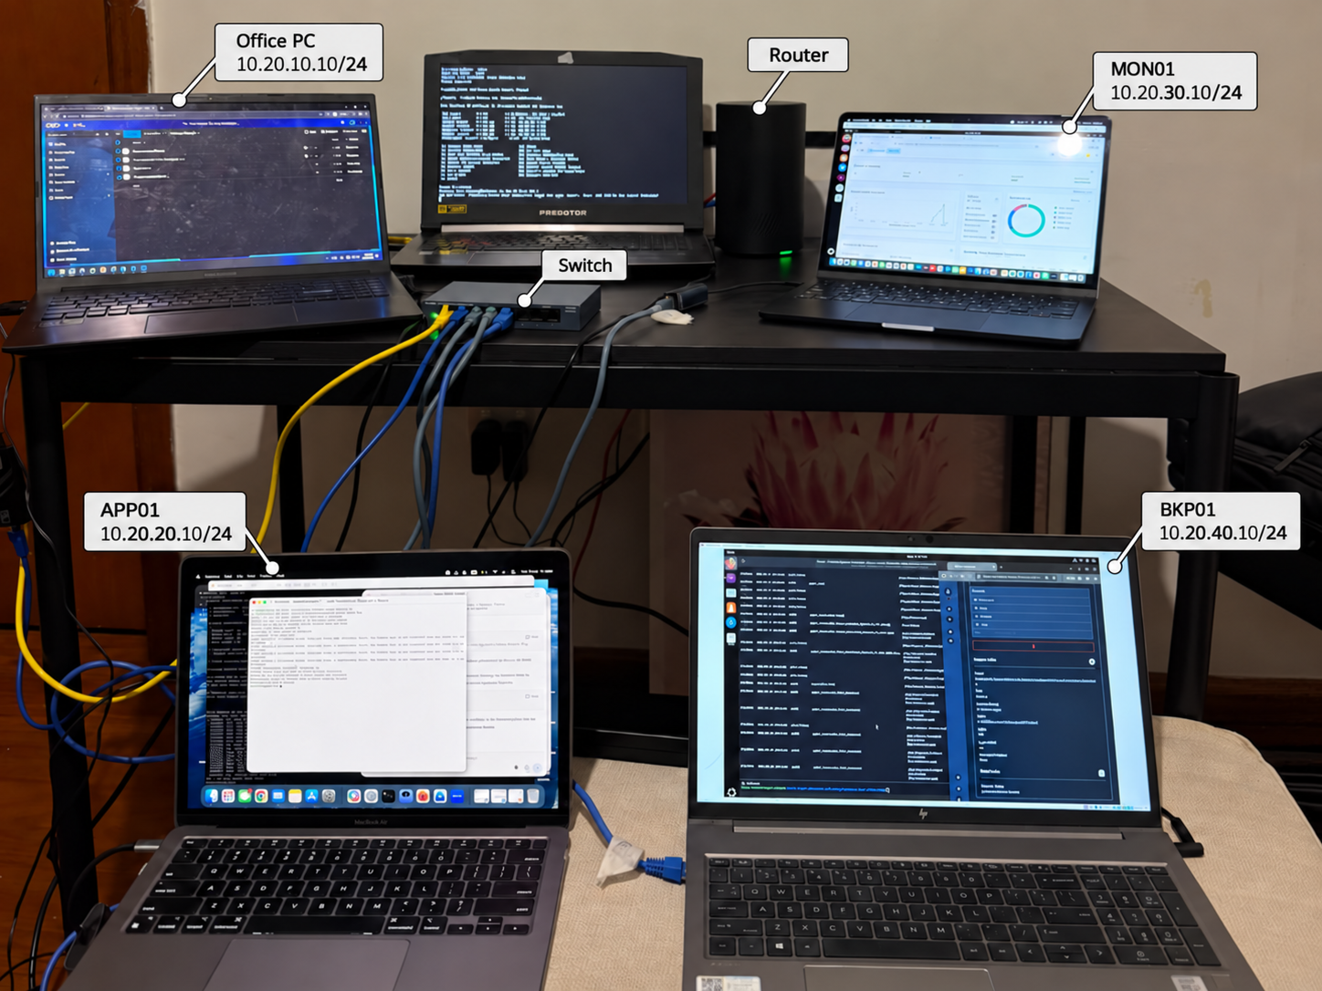
Figure 1. Physical AG-3 prototype setup used during integration and validation.

4 Testing Method
The team tested the prototype by actually doing actions on the implemented services, and capturing the visible outcome. The Office PC and Nextcloud were used for application tests. Wazuh was used on MON01 for monitoring tests. Backup tests were done with Restic (APP01) and MinIO (BKP01). The completed service-path checks (FT-01 to FT-15) from the AG3 Firewall, Segmentation and Access Control Design were used as the basis for the firewall tests. The file-impact test was a controlled ransomware-like attack, and not performed with actual malware - just with synthetically created files in a separate test folder. Evidence is organized in a sequence that is practical. For each test, the test is described, observations made, and conclusions drawn about the prototype.

5 Prototype Setup and Integrated Validation
The integrated validation starts with normal user access and progresses to monitoring, backup and recovery. Prototype is an order of behavior that is not that of separate devices.

5.1 Office PC Access to APP01
The first test verified that the Nextcloud service on APP01 was accessible via the approved Office-to-Server path by a normal Office user. The Office PC opened the Nextcloud login page at 10.20.20.10 and the user was able to log in successfully. Upon logging in, a Nextcloud Dashboard appeared. This demonstrated that the business application was accessible from the Office network and not just on APP01 for local access.
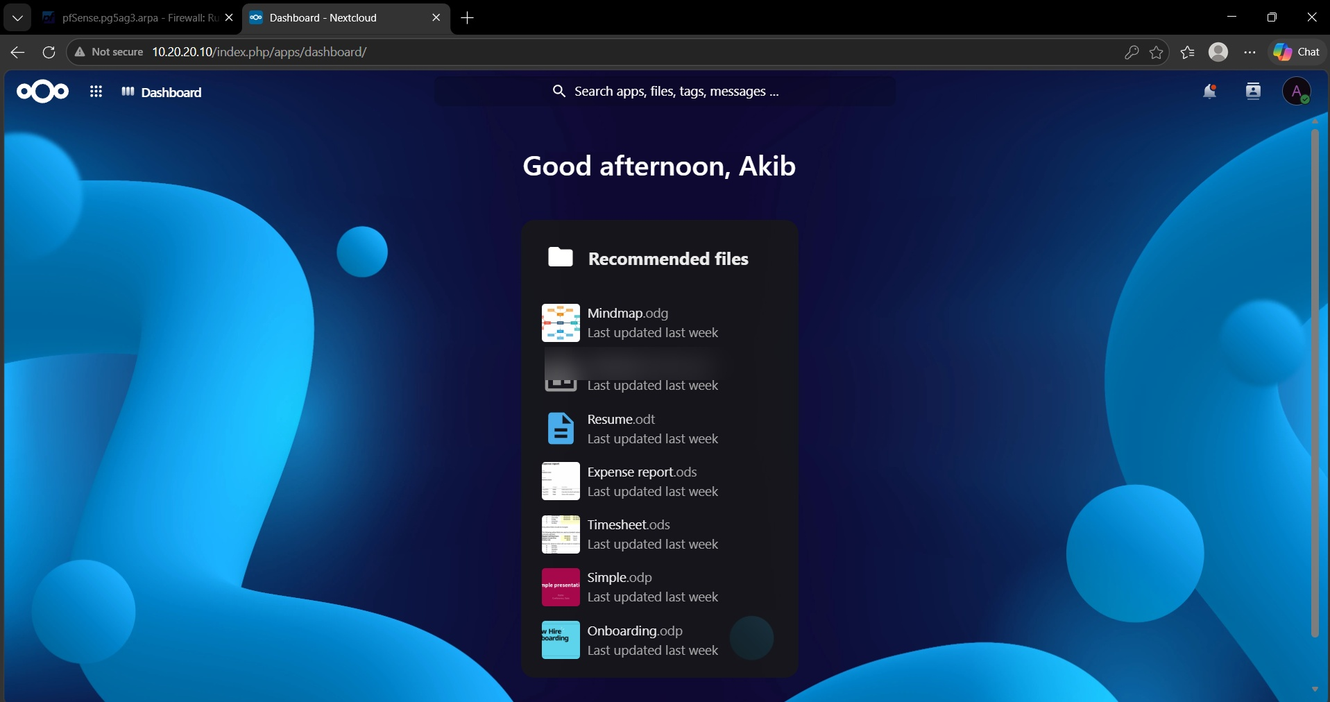
Figure 2. Office PC opening the Nextcloud login page on APP01 at 10.20.20.10.
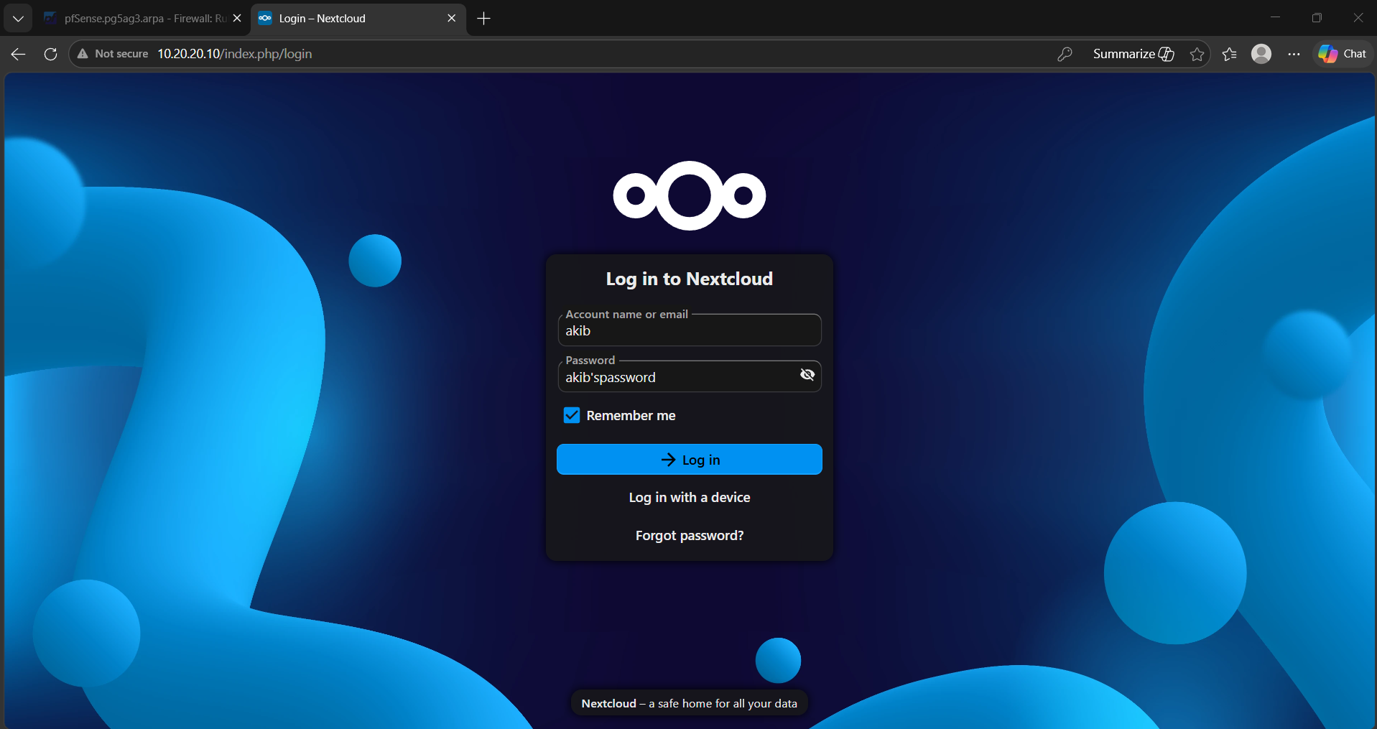
Figure 3. Authenticated Nextcloud dashboard displayed after the Office user logged in to APP01.

Test | How it was performed | Observed result | What it proved
Office PC to APP01 Nextcloud | Opened 10.20.20.10 from the Office PC and authenticated to Nextcloud | Login completed and the user dashboard was displayed | The approved user-side path to the business application was working

5.2 Authentication Monitoring
Authentication monitoring was checked from MON01 using the Wazuh Threat Hunting dashboard. Another monitoring view displayed authentication failures and authentication successes. This shows that MON01 can be used to have a single place to see the authentication activity from the monitored environment.
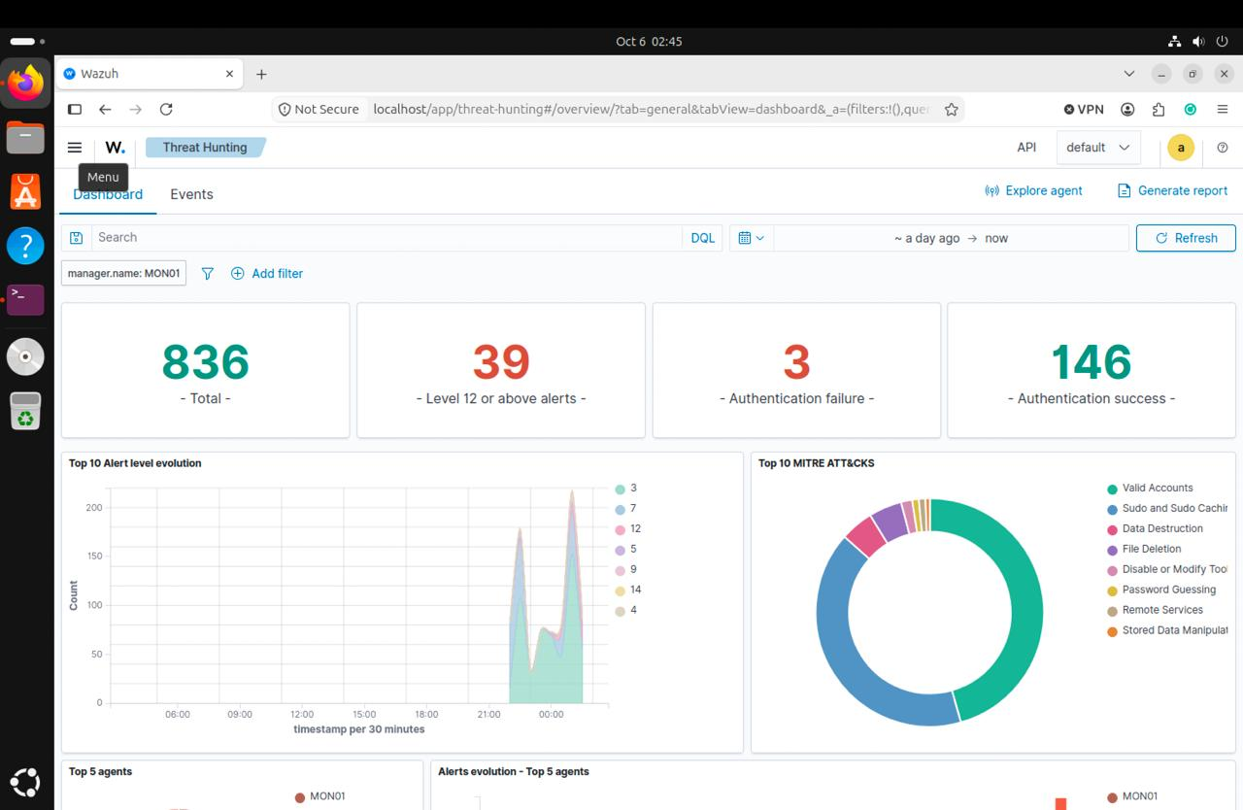
Figure 4. Wazuh Threat Hunting dashboard on MON01 showing authentication-failure and authentication-success activity.
Test | How it was performed | Observed result | What it proved
Authentication monitoring | Generated and reviewed authentication activity and opened the Wazuh Threat Hunting dashboard | Wazuh displayed authentication failures and authentication successes in the same monitoring view | MON01 can centrally show authentication activity for investigation

5.3 File Integrity Monitoring
A test was performed to verify if the modifications done on APP01 monitored data were detected by the File Integrity Monitoring test in Wazuh. Events on the file were recorded by the APP01 agent and were displayed on the dashboard. The event view would also show the file path, event action, rule description and rule identifier. This means that there is direct evidence of changes to files on APP01 that can be detected and reviewed on MON01.
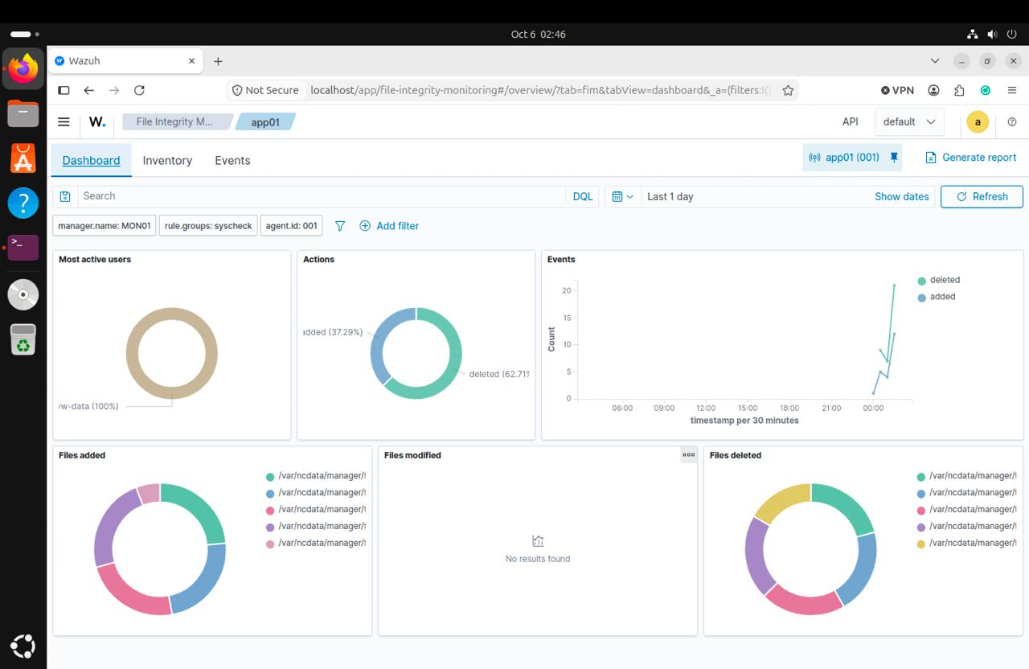
Figure 5. Wazuh File Integrity Monitoring dashboard for APP01 showing file actions and event activity.

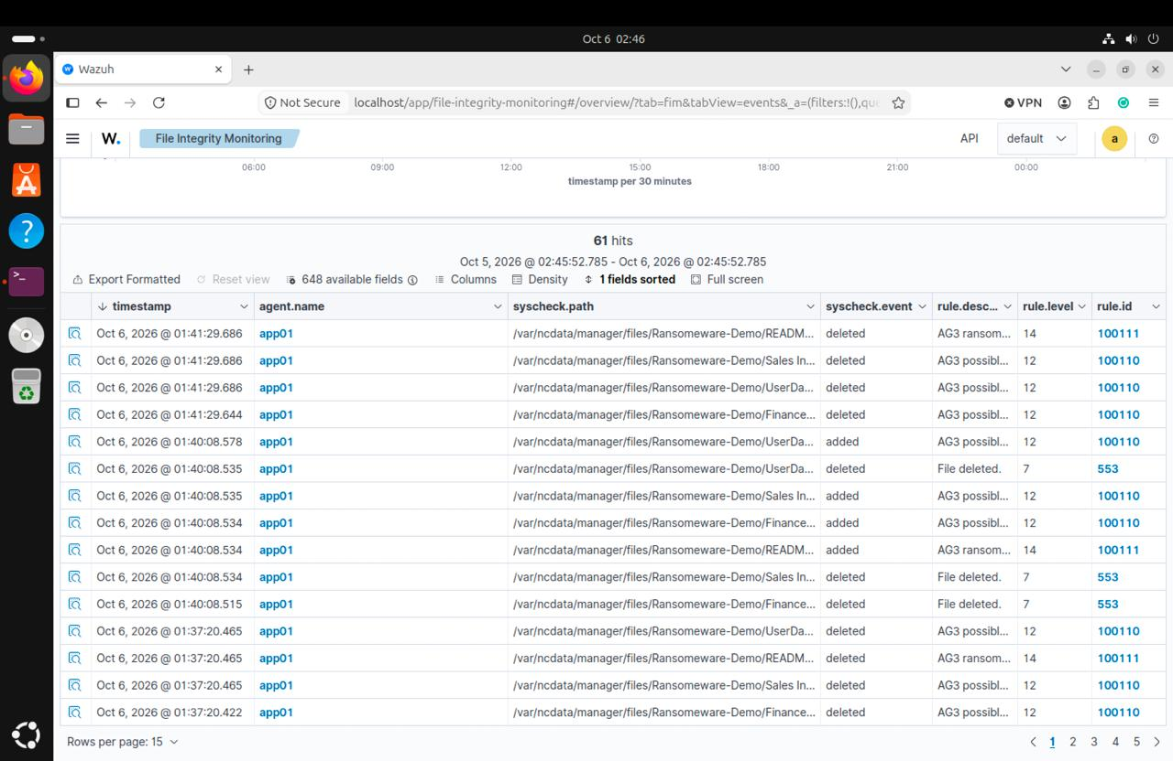
Figure 6. Wazuh FIM event view showing detailed APP01 file events, paths and actions.

Test | How it was performed | Observed result | What it proved
File Integrity Monitoring | Created, changed and removed files inside a Wazuh-monitored APP01 path and reviewed the FIM dashboard | APP01 events appeared in Wazuh with file paths and event actions | Important file changes on APP01 can be detected centrally by MON01

5.4 Successful Backup
The backup test tested the actual backup process and not just the network connect. APP01 was set to run the AG-3 Nextcloud backup every 4 hours. The Restic backup script ran and processed data, saved snapshot and gave a message BACKUP_SUCCESS. This means that APP01 can generate a backup and upload the data to be protected to the backup repository.
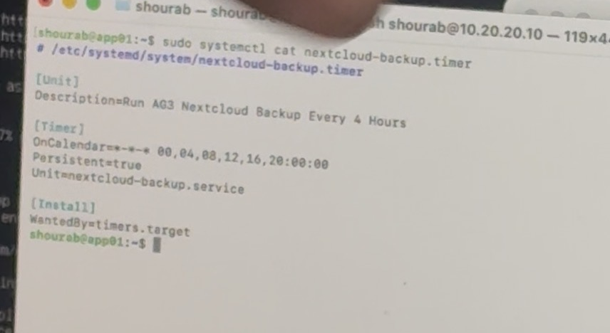
Figure 7. APP01 systemd timer configured to run the AG-3 Nextcloud backup every four hours.
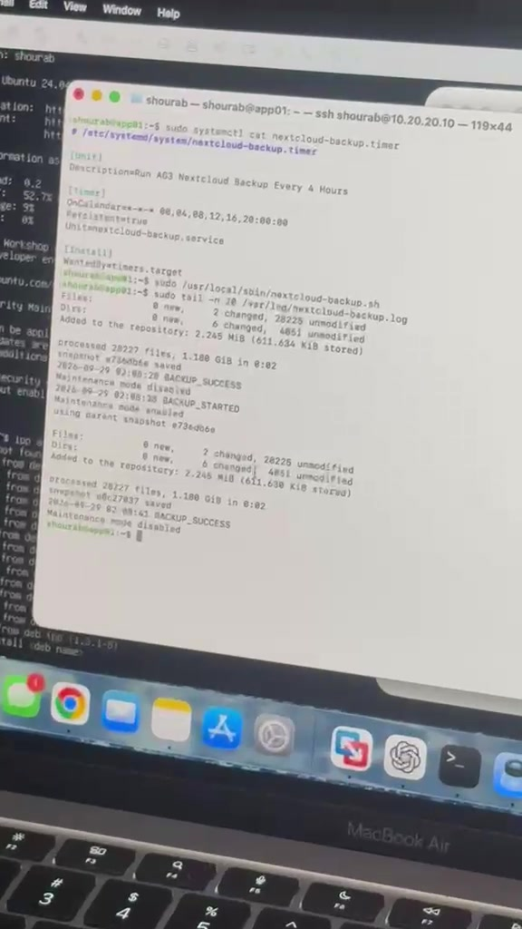
Figure 8. APP01 Restic output showing a completed backup, saved snapshot and BACKUP_SUCCESS result.

Test | How it was performed | Observed result | What it proved
Successful Restic backup | Ran the APP01 backup script against the configured Restic/MinIO repository | Restic processed the data, saved a snapshot and recorded BACKUP_SUCCESS | The APP01 backup workflow is operational

5.5 Controlled Backup Failure
A controlled failed backup was also generated to enable the team to test the failure behaviour. APP01 has reported BACKUP_FAILED if the backup process failed. The AG-3 backup dashboard on MON01 then showed backup events that were failed and backup events that were successful. This is crucial since a resilience system ought to indicate failed backups as well as record successful backups.
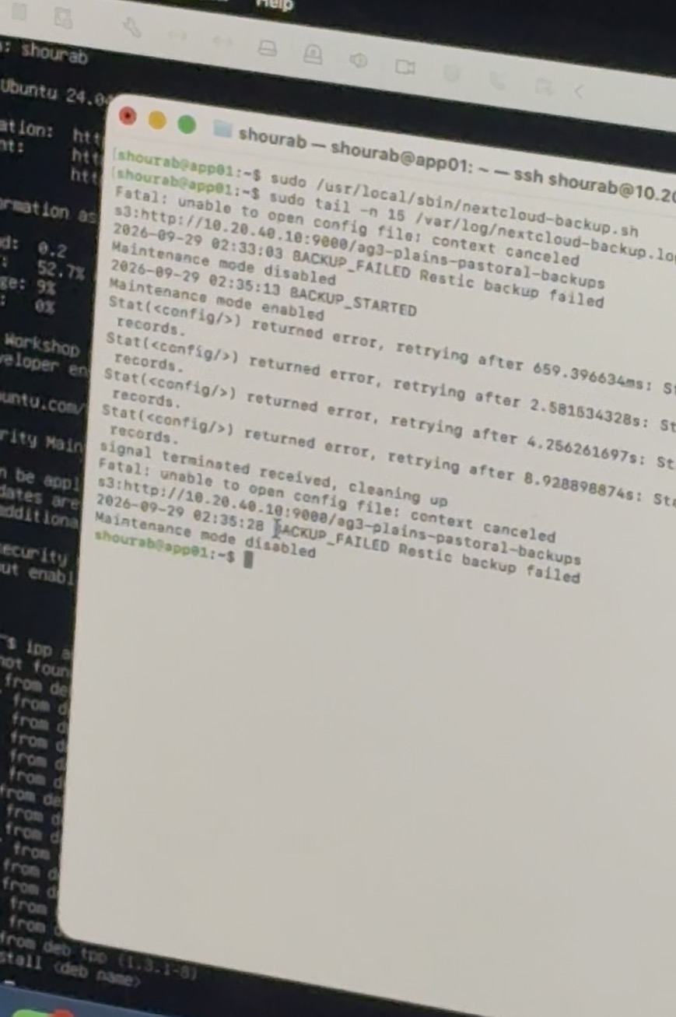
Figure 9. APP01 output showing the controlled Restic backup failure and BACKUP_FAILED result.
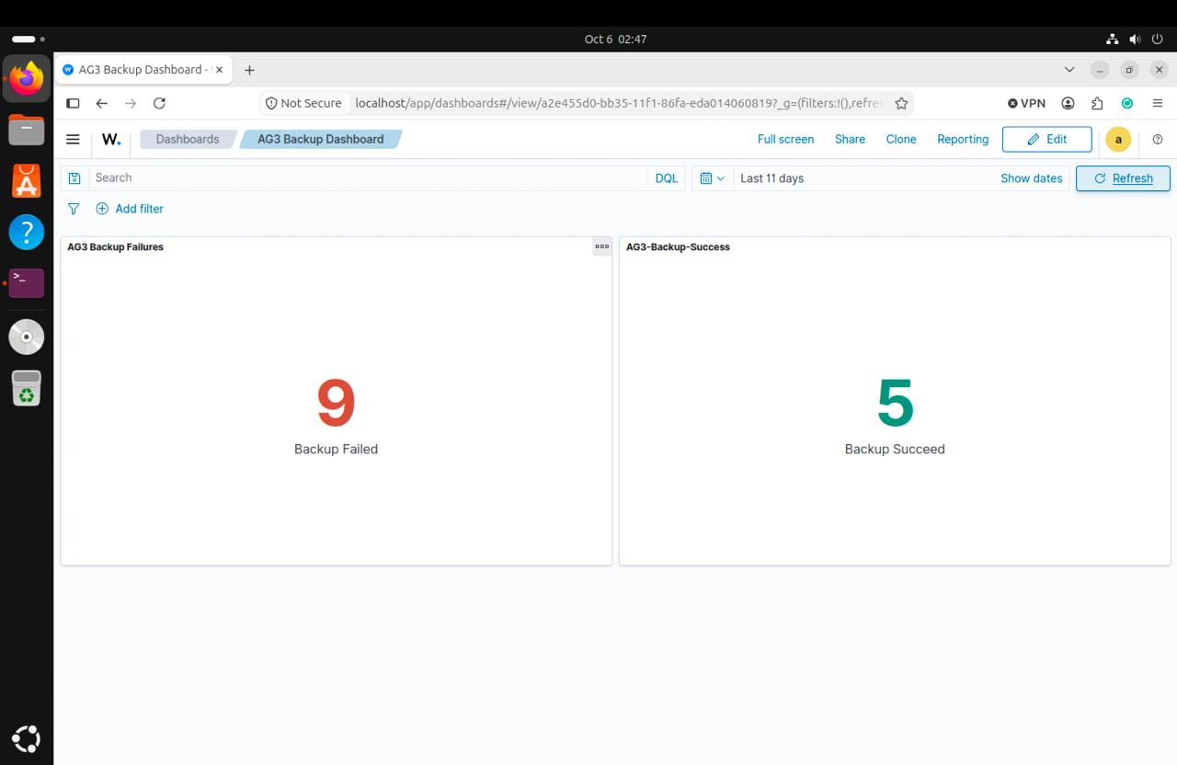
Figure 10. AG-3 Backup Dashboard on MON01 showing recorded backup-failure and backup-success events.

Test | How it was performed | Observed result | What it proved
Controlled backup failure | Forced the backup process into a failed state and reviewed the AG-3 backup monitoring dashboard | APP01 recorded BACKUP_FAILED and MON01 showed failed and successful backup activity | Backup failures are visible centrally for investigation

5.6 Backup Stored in MinIO
The next test was to test the storage part of the backup. The MinIO Object Browser on BKP01 displayed the ag3-plains-pastoral-backups bucket and the objects in the repository, which uses the snapshots path. A review of the visible timestamps indicated presence of the latest snapshots (APP01) in the repository, which were used in project demonstrations.
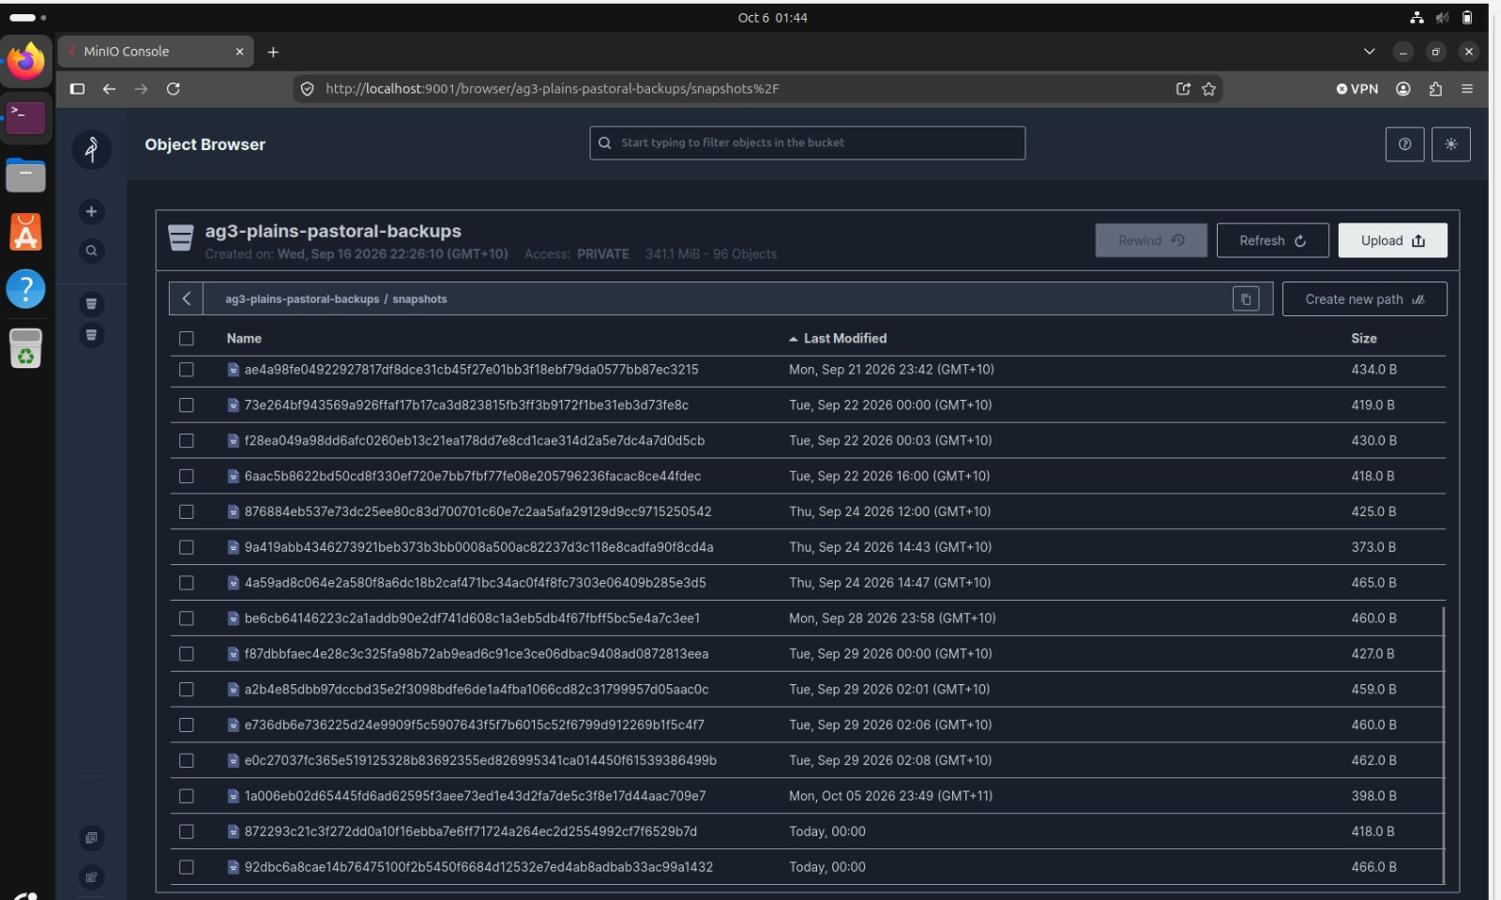
Figure 11. MinIO Object Browser on BKP01 showing the AG-3 backup bucket and stored repository objects.

Test | How it was performed | Observed result | What it proved
MinIO backup storage | Opened the MinIO Object Browser on BKP01 and inspected the backup bucket | Repository objects and current snapshot objects were visible in the backup bucket | The Restic repository is stored on the dedicated backup server

5.7 Controlled Ransomware-Like File Impact and Recovery Test
The ultimate integrated test mimicked ransomware-type file attack, but without real ransomware. The team set up a Ransomware-Demo folder with synthetic business files. The team took a clean Restic snapshot in the first place to have a known good recovery point. A controlled script was then put in place to replace the normal demo files with locked versions. This simulated the type of file-impact behavior typically seen with ransomware, but without the danger of this test being on real data.
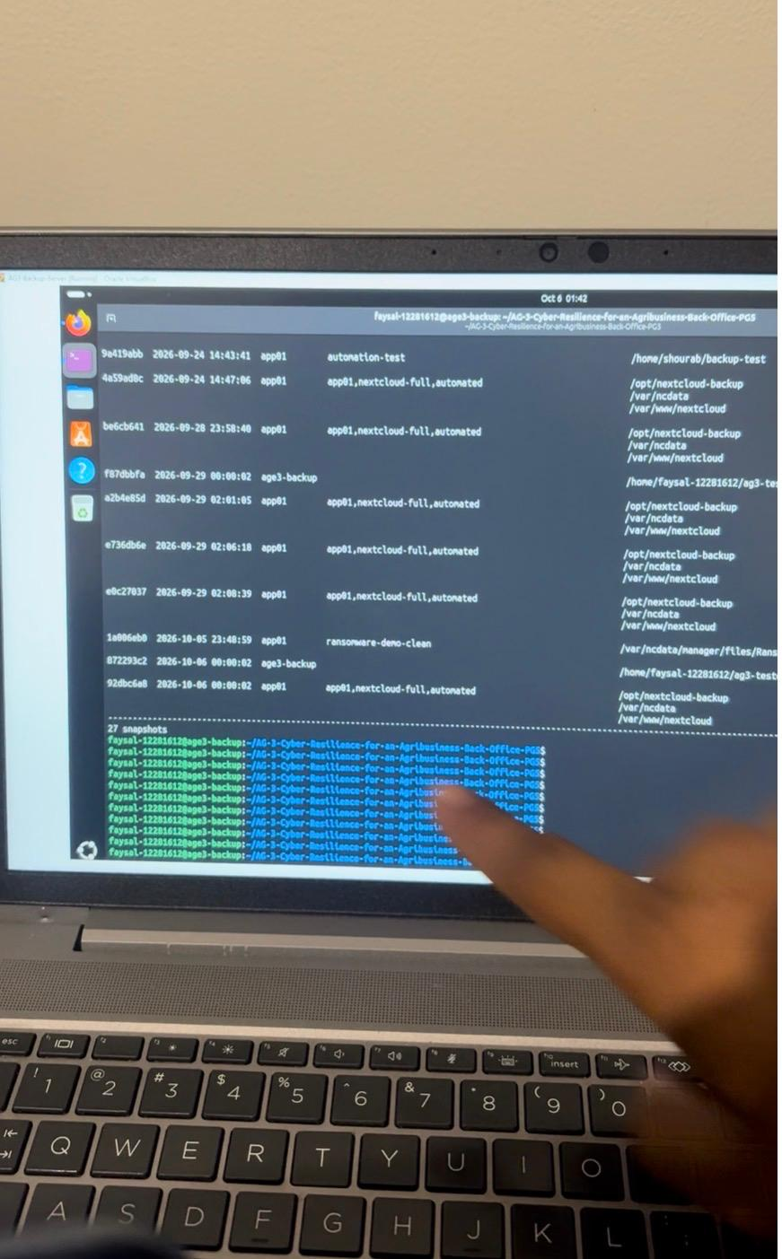
Figure 12. Restic snapshot list showing the known-good ransomware-demo-clean snapshot created before the controlled impact.
Upon execution of the script, the extension of the files Finance, Sales and UserData appeared as .locked. Wazuh captured the resulting file activity and the monitoring dashboard showed the number of events. This showed the monitoring part of the test as the abnormal ransomware-like file-impact behaviour on APP01 was seen on MON01.
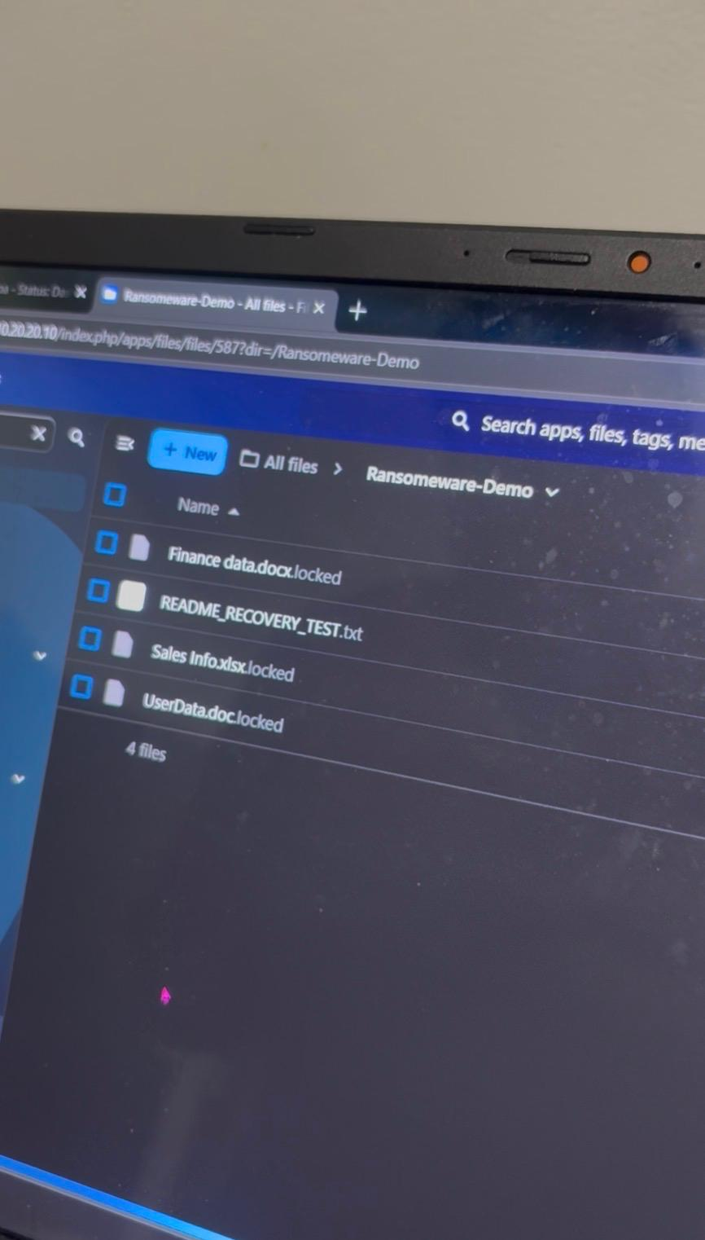
Figure 13. Ransomware-Demo folder after the controlled impact, showing the synthetic business files in the locked state.
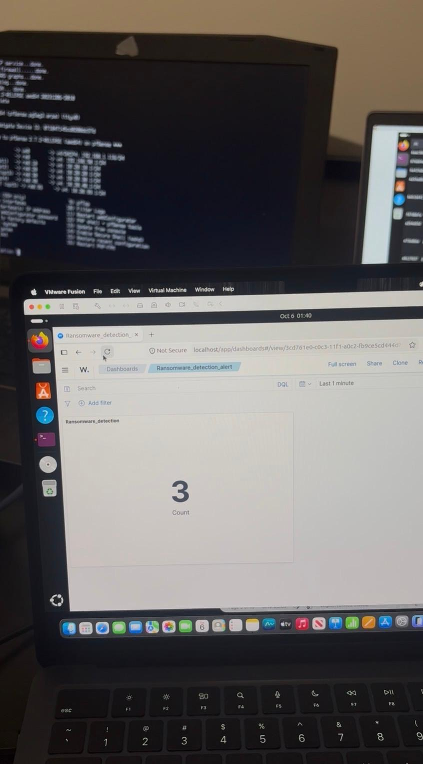
Figure 14. Wazuh dashboard showing alerts generated during the controlled ransomware-like file impact.
Then, the recovery script was executed from APP01 with the clean Restic snapshot created above. The script applied to BKP01/MinIO to recover the protected files, replace the corrupted test folder and update the Nextcloud index. The recovered files were then again accessible in Nextcloud without the locked extension. This marked the end of the Protect-Detect-Recover process the prototype was designed to illustrate.
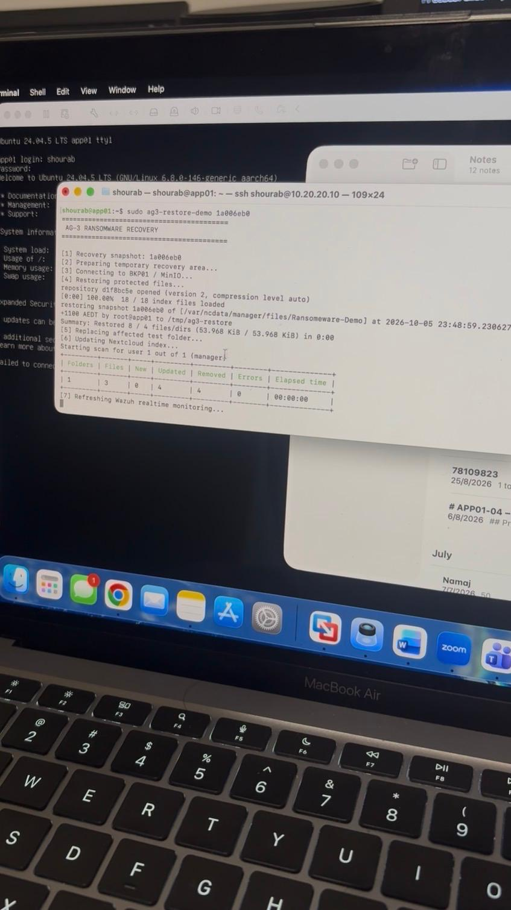
Figure 15. APP01 recovery script restoring the Ransomware-Demo data from the known-good Restic snapshot stored on BKP01.
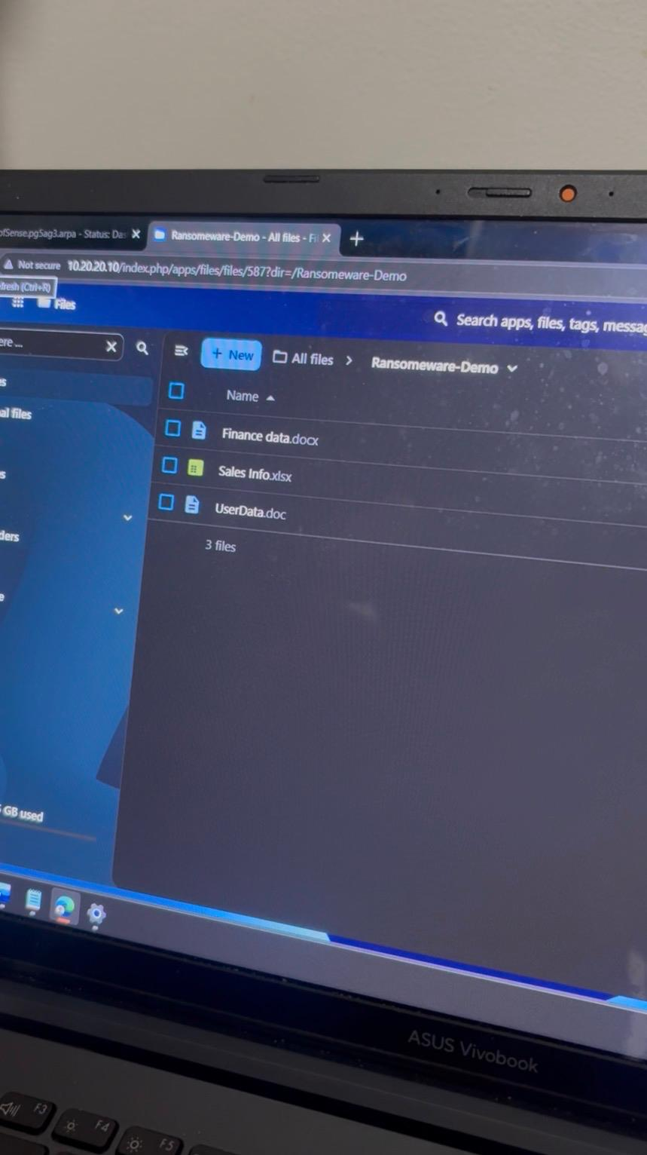
Figure 16. Ransomware-Demo files visible in their normal unlocked form after recovery.

Stage | What was done | Observed result | What it proved
Known-good backup | Created a clean Restic snapshot before the impact | The ransomware-demo-clean snapshot was present in the repository | A clean recovery point existed before the simulated incident
Controlled impact | Ran a safe script against synthetic Ransomware-Demo files | Normal files were replaced by locked files | The prototype reproduced ransomware-like file-impact behaviour without real malware
Detection | Reviewed Wazuh monitoring during the impact | Ransomware-related file events and alerts were visible in Wazuh | MON01 can detect and present abnormal file activity
Recovery | Ran the recovery script using the clean Restic snapshot from BKP01/MinIO | The affected test folder was restored, and normal files were available again in Nextcloud | The backup repository can recover the protected data after the controlled impact

5.8 What the Integrated Tests Proved
The integrated tests show the primary end-to-end prototype workload: user's access to APP01 was approved, there was central monitoring on MON01, backup from APP01 to BKP01, and recovery of synthetic files, which was achieved after a controlled ransomware-like file attack. The consolidated results and consolidated requirements traceability are provided in Sections 9 and 10.

6 Firewall and Segmentation Validation
The tests in the completed AG3 Firewall, Segmentation and Access Control Design (FT-01 to FT-15) have been reused as the firewall validation. Service paths that were required were connected, and service paths that were not required were not connected.
ID | Source | Destination / service | Observed result | What it proved
FT-01 | APP01 | MON01 TCP 1514 | Connection succeeded | Wazuh telemetry path available
FT-02 | APP01 | MON01 TCP 1515 | Connection succeeded | Wazuh enrolment path available
FT-03 | APP01 | BKP01 TCP 9000 | Connection succeeded | Backup API path available
FT-04 | BKP01 | MON01 TCP 1514 | Connection succeeded | Firewall permits the approved BKP01-to-MON01 TCP 1514 path
FT-05 | BKP01 | MON01 TCP 1515 | Connection succeeded | Firewall permits the approved BKP01-to-MON01 TCP 1515 path
FT-06 | APP01 | BKP01 TCP 22 | Connection did not establish | Unnecessary SSH path unavailable
FT-07 | MON01 | BKP01 TCP 9000 | Connection did not establish | Monitoring host cannot access backup API
FT-08 | BKP01 | APP01 TCP 443 | Connection did not establish | Backup host cannot initiate APP01 HTTPS
FT-09 | MON01 | APP01 TCP 22 | Connection did not establish | MON01 cannot SSH to APP01
FT-10 | MON01 | BKP01 TCP 22 | Connection did not establish | MON01 cannot SSH to BKP01
FT-11 | BKP01 | MON01 TCP 22 | Connection did not establish | BKP01 cannot SSH to MON01
FT-12 | BKP01 | APP01 TCP 22 | Connection did not establish | BKP01 cannot SSH to APP01
FT-13 | APP01 | BKP01 TCP 9001 | Connection did not establish | APP01 cannot access MinIO admin console
FT-14 | APP01 | MON01 TCP 22 | Connection did not establish | APP01 cannot SSH to MON01
FT-15 | MON01 | APP01 TCP 443 | Connection did not establish | MON01 cannot initiate APP01 HTTPS

FT-04 and FT-05 only verify the reachability of a firewall. They don't mean that a Wazuh agent was enrolled in BKP01 or that the events in BKP01 were collected by MON01.
The detailed command output and screenshots of pfSense rules are not repeated again in this validation report but are found in the AG3 Firewall, Segmentation and Access Control Design.

7 Application and Access-Control Validation
The completed Nextcloud access-control evidence has been reused as well. These tests demonstrate that when a user reaches APP01, he or she does not necessarily have access to all business folders. Network access and permissions for applications are still two different things.
Control | Observed result | What it proved
Finance user - Finance folder | Finance data was available according to the assigned permission | The assigned role can access its approved data
Finance user - unrelated department data | Unrelated department data was blocked or not presented | Department data is separated inside the application
Management / role-specific folder visibility | Only approved folders were visible | Application RBAC limits business-data visibility
Nextcloud administrator MFA | A TOTP challenge appeared after the password step | Privileged Nextcloud access uses an additional authentication factor

8 Problems Found and Resolved During Testing
The first prototype didn't work out perfectly. The problems below illustrate how the team progressed from individual parts to a functional integrated environment.
Issue | Observed effect | Action taken | Final outcome
Unmanaged switch limitation | The LS108G could not enforce production switch-port VLAN membership | Used the switch only for physical connectivity and kept logical policy on pfSense and host interfaces | The prototype remained usable while the target design continued to require managed switching
HTTPS / MTU integration issue | APP01 TCP 443 was reachable but the Nextcloud HTTPS session stalled | Reduced the APP01 integration-interface MTU during troubleshooting | Office-to-Nextcloud access worked normally after the change
Firewall rule/path changes | Some required paths were initially blocked during integration | Changed only the required firewall rules and retested the service paths | The final FT-01 to FT-15 results matched the intended policy
Firewall states after rule changes | Existing states could affect a retest after policy changes | Cleared or checked states before the final retest | The final result reflected the active firewall policy
Controlled backup failure | Backup was intentionally made to fail for monitoring validation | Used the failed state as a monitored event | APP01 recorded BACKUP_FAILED and MON01 displayed the backup-failure activity

9 Consolidated Validation Results
Validation area | Evidence used | Result demonstrated
Prototype setup | Figure 1 and setup recording | The main prototype systems were connected and used together
Office application access | Figures 2-3 | Office user reached APP01 and authenticated to Nextcloud
Authentication monitoring | Figure 4 | MON01 displayed authentication failure and success activity
File Integrity Monitoring | Figures 5-6 | APP01 file events were detected and reviewable in Wazuh
Successful backup | Figures 7-8 | APP01 created a Restic snapshot and recorded BACKUP_SUCCESS
Failed backup monitoring | Figures 9-10 | The controlled failure produced BACKUP_FAILED and was visible on MON01
Backup storage | Figure 11 | The Restic repository objects were stored in MinIO on BKP01
Controlled ransomware-like file-impact detection | Figures 12-14 | Synthetic business files were locked and the resulting abnormal file activity was visible in Wazuh
Ransomware recovery | Figures 15-16 | The clean snapshot was restored and the files became available again in normal form
Firewall service paths | FT-01 to FT-15 | Required service paths worked and unnecessary paths were unavailable
Application RBAC / MFA | AG3 Firewall, Segmentation and Access Control Design evidence | Role-based folder access and administrator TOTP were demonstrated

10 Requirements Traceability
The following table provides a correlation between the key prototype requirements and evidence for this report. This allows a direct link between the project objectives and what was demonstrated during testing.
Requirement | Validation evidence | What was demonstrated
Office users can reach the business application | Figures 2-3 | Nextcloud on APP01 was reachable and usable from the Office PC
Authentication activity is centrally visible | Figure 4 | Wazuh on MON01 displayed authentication failure and success activity
Important file changes are centrally visible | Figures 5-6 | Wazuh recorded APP01 File Integrity Monitoring events
APP01 can create backups | Figures 7-8 | Restic created a new backup snapshot
Backup failure can be monitored | Figures 9-10 | The failed backup was recorded by APP01 and visible on MON01
Backup data is stored on BKP01 | Figure 11 | MinIO on BKP01 stored the repository objects
Ransomware-like file impact can be detected safely | Figures 12-14 | Synthetic files were locked and the activity was detected in Wazuh
Protected data can be recovered after the controlled impact | Figures 15-16 | APP01 restored the clean files from the previous Restic snapshot
Required service paths are available and unnecessary paths are restricted | FT-01 to FT-15 | Firewall behaviour matched the intended service-level policy
Business data is role-restricted | Nextcloud access-control evidence | Application permissions limited folder visibility and privileged login used TOTP

11 Validation Limitations
The prototype is a proof-of-concept and not a production deployment. TP-Link LS108G is unmanaged and will not enforce production switch-ports VLAN. The test environment as well only consists of a small subset of hosts instead of the full head-office target environment. Outside of this prototype validation is high availability, production wireless coverage, CCTV/RFID, AUTH01, NAS01, and Guest Wi-Fi and the full target IPv6 design.
The file-impact test is a ransomware simulation and is safe to use. It employs synthetic files and a controlled script which transforms the test data into locked versions. No actual ransomware/destructive malware was activated. The test thus validates the detection and recovery workflow without any extra risk.

12 Conclusion
The prototype shows the main components of the AG-3 cyber-resilience solution can perform as a single solution. The Office PC can connect to APP01 and utilize Nextcloud. Authentication activity and File Integrity Monitoring events can be displayed in MON01. APP01 can successfully make a Restic backup and a controlled failed backup can be seen in monitoring. BKP01 backs up the backup repository to MinIO. Firewall service tests are also performed, indicating the availability of the required paths and the restriction of unnecessary service paths.
The ransomware-like file-impact test was executed in a controlled manner and was a key part of the primary resilience workflow. Then, synthetic business files were created, a clean backup was performed, these files were placed in a locked state, Wazuh showed the abnormal file activity, and the previous clean files were restored from the backup repository. This illustrates the AG-3 prototype's Protect, Detect and Recover strategy for a small agribusiness back office.

Appendix A - Recorded Demonstration Evidence
The following demonstrations were used as supporting prototype evidence. Screenshots from the same demonstrations are kept beside the relevant tests in the main body so the result can be followed directly from the document.

Video | Demonstration | Link
V01 | Overall prototype and physical setup | Video Link
V02 | Evidence of secure access of our File server & MFA | Video Link
V03 | Evidence Of File Integrity Monitoring | Video Link
V04 | Evidence That Wazuh can monitor Backup successful and failed attempt | Video Link
V05 | Evidence of Backup server Backing-up Encrypted Data | Video Link
V06 | Secure Ransomware Attack and Appropriate Remedy | Video Link

